**Murder Mystery USING SQL**

**By**

**Mariam Ohunene Yusuf**

**Overview**

This report is based on the analysis carried out on a Murder Case.

We are going to be working with six (6) tables, namely; crime_scene_report, person, get_fit_now_member, get_fit_now_check_in, drivers_license, and interview which are downloaded in our database.

Case Study: A crime has taken place and the detective needs your help. The detective gave you the crime scene report, but you somehow lost it. You vaguely remember that the crime was a murder that occurred sometime on Jan.15, 2018, and that it took place in SQL City. Start by retrieving the corresponding crime scene report from the police department’s database.

**Analyse**;

Before bringing the analysis part, let’s check the first five rows of the crime_scene_report table. I used SQLite as my IDE.

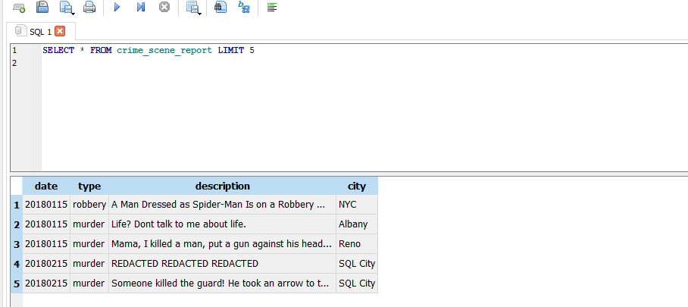

Okay, it is time to perform our data analysis on the dataset.

1. **Crime Scene Report**;

First let’s retrieve the crime scene report for a murder that occurred on January 15, 2018, in SQL City.

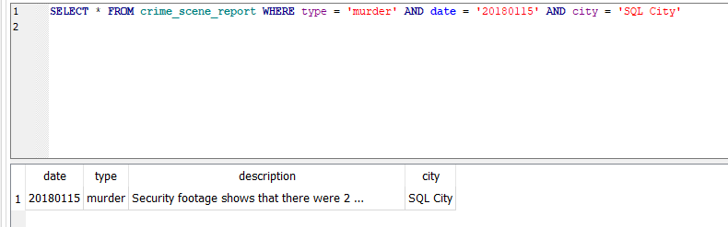

The **description column** shows that there were 2 witnesses. The first witness lives at the last house on "Northwestern Dr". The second witness, named Annabel, lives somewhere on "Franklin Ave". Let’s first our first witness.

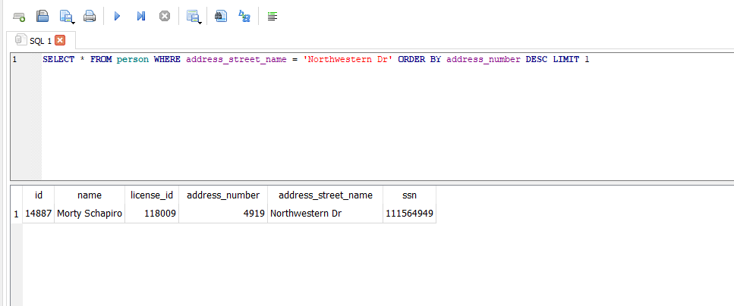

From the query result, we now know the first witness's name, license ID, and SSN.

Now let's get more information on our second witness.

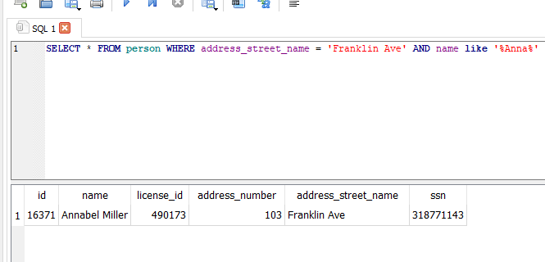

The result shows more information on the second witness such as license ID, address number, and SSN.

**HERE ARE ALL THE INFORMATION ON OUR WITNESSES;**

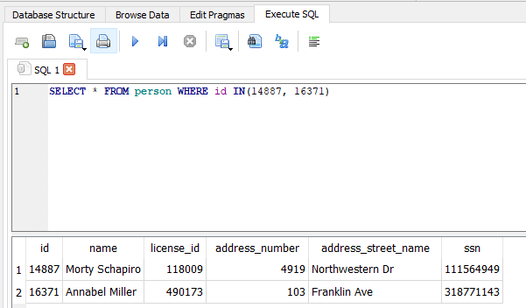

1. **Testimony**

Now let's get our witness testimonies from the **interview table;**

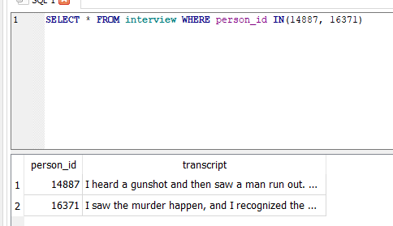

First witness – “I heard a gunshot and then saw a man run out. He had a "Get Fit Now Gym" bag. The membership number on the bag started with "48Z". Only gold members have those bags. The man got into a car with a plate that included "H42W".

Second witness – “I saw the murder happen, and I recognized the killer from my gym when I was working out last week on January the 9th”.

**From the query result**, we got the suspect gym membership, license number, and when he was last seen before the murder.

1. **Killer Found**

Now let’s use all the information we gathered from the testimonies to catch the killer. We are going to use join specifically inner join to extract the information we need to catch the killer. We are going to be joining the drivers_license table, person table, get_fit_now_check_in, and get_fit_now_member table.

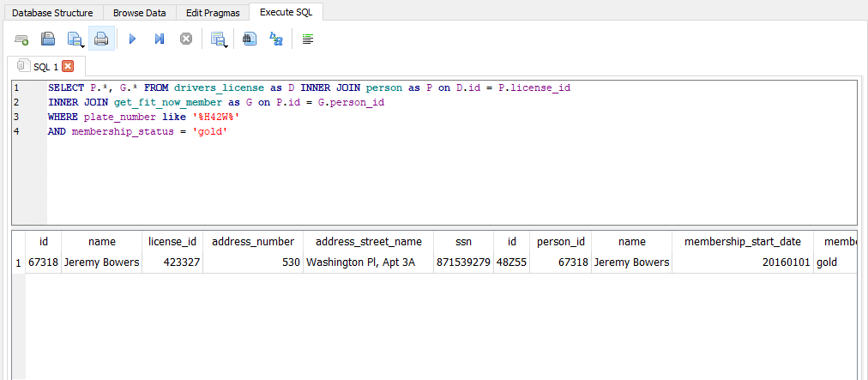

From the result, we got the killer whose name is Jeremy Bowers. To be sure we are right, let's check his last check-in.



We still have the same name which means we found our killer and his name is **Jeremy Bowers.**